LASC Guy Harvey Memorial Workshop Fund

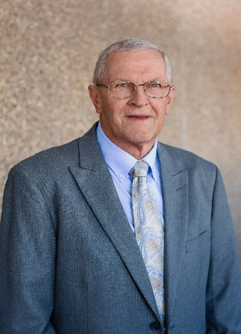
Guy Louie Harvey
1944-2019

In February of 2019 LASC lost one of its most enthusiastic supporters when “Mr. Guy” as we all knew him passed away. For over 40 years Mr. Guy co-sponsored the Thibodaux High Student Council and was an active member of the LASC Board. Even after he retired 17 years ago he continued to travel to every student council event in our state and our country. There was one activity that was very dear to him….
LASC Summer Leadership Workshop
- To honor Mr. Guy and his devotion to LASC we, along with his family, are establishing the LASC Guy Harvey Memorial Workshop Fund.
- Each year from September to December 15th schools can send their donation to the fund. For each $100 sent they will get one ticket for the workshop drawing at LASC Convention in January.
- At the advisor meeting, names of schools will be picked for registration scholarships to that year’s leadership workshop. Separate drawings will be conducted for middle level and high school.
Please support this most worthwhile fund. Please complete the form and mail your form and check by December 15th.
*The Guy Harvey Workshop Scholarship Program is now our state charity for each year. It has been added to the application for the Gold and Silver Award.

Donation to the LASC Guy Harvey Memorial Workshop Fund

Name of School___________________________________
Circle one: Middle level High School
Name of Advisor__________________________________
Advisor email_____________________________
_____Although our school is donating to the fund we DO NOT want to be included in the scholarship drawing at convention.
Please make check payable to:
LASC Guy Harvey Memorial Workshop Fund
Mail this form and your check to: Beth David
Thibodaux High School
1355 Tiger Drive
Thibodaux, LA 70301
Advisors will be notified by email when their donation has been received.
Amount of donation___________________________
Check number__________
Date mailed______________________
- Remember to be eligible for the drawing at the 2024 convention the donation must be received by December 15, 2023. Any donations received after that date will be applied to the drawing at the next convention.
Please contact Beth David at bdavid103@aol.com with questions

Further Information about the Guy Harvey Workshop Scholarship

- Schools awarded scholarships must choose a student who has never attended workshop(at that level) before.
- Students chosen must be a current student council member or class officer.
- Schools awarded may not save their scholarship for another year.
- The scholarship only covers the cost of registration fees to attend LASC Leadership Workshop.
- In choosing the recipient of the scholarship please select a student who, without the scholarship, might not be able to attend workshop.
- Recipients of the scholarship must be registered along with the regular delegation of the school.
- Students attending the Plus Program are not eligible for the scholarship.
- The cost of the workshop scholarship will be directly deposited to LASC from the Scholarship Fund.
- Students receiving scholarships may be recognized at a general session at workshop.
- During workshop the scholarship recipients will meet.

Please note: Participation in this activity is totally voluntary.
It is a way for our state organization to honor
one of its best and his memory. We hope that
it will allow more students to attend our LASC
Workshop.

Please contact Beth David(bdavid103@aol.com) with any questions.

